**Name :-*Shreyas Mahesh Dambe***

**Collage Name:-*Sinhgad Institute of Management and Computer Application,pune (MCA-II)***

**Internship*:- PHN Technology***

***___________________________________________________________________________***

**Web Development Task 2**

Task Description:

You are required to prepare a home page for an Engineering college using HTML and CSS. In this task,

you need to use CSS inside HTML and do not create an external CSS file. You should include the

following headlines: "About us," "Department," "Faculty," "Research," and "Placement", “Contact us”

Within the Department section, include all the streams/branches offered by the college. You should use

internal styling to apply the necessary styles to your HTML elements. After completing the task, you

need to copy the code and convert it into a PDF file and take screenshots of the output.

**Source Code:-**

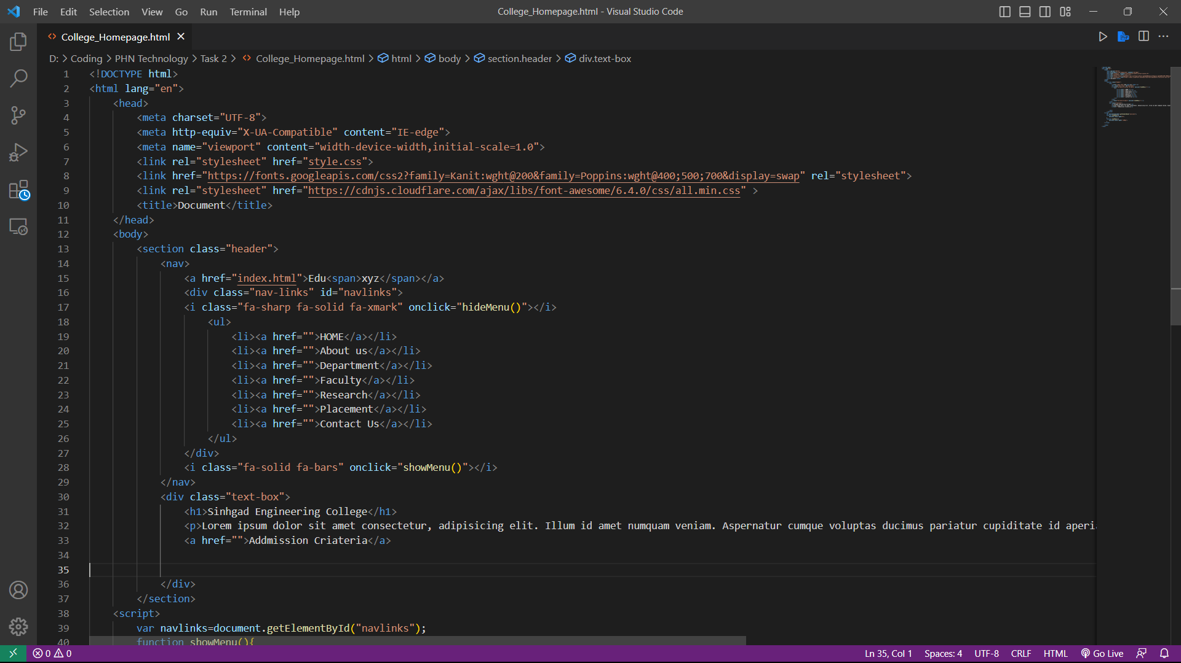

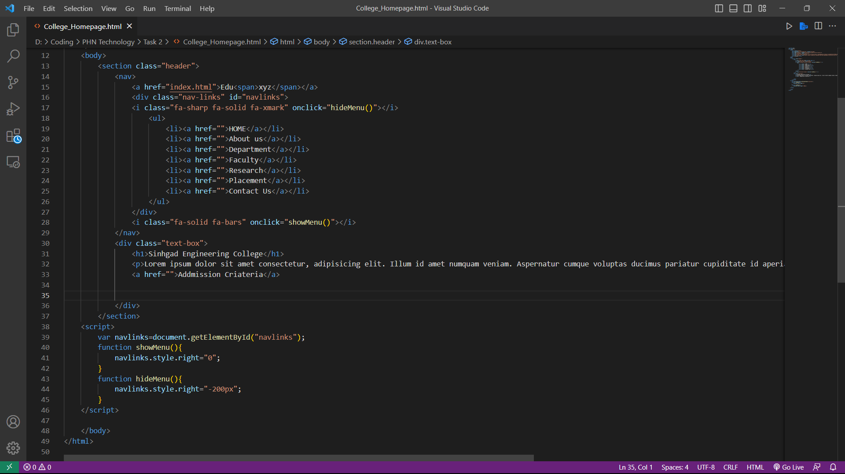

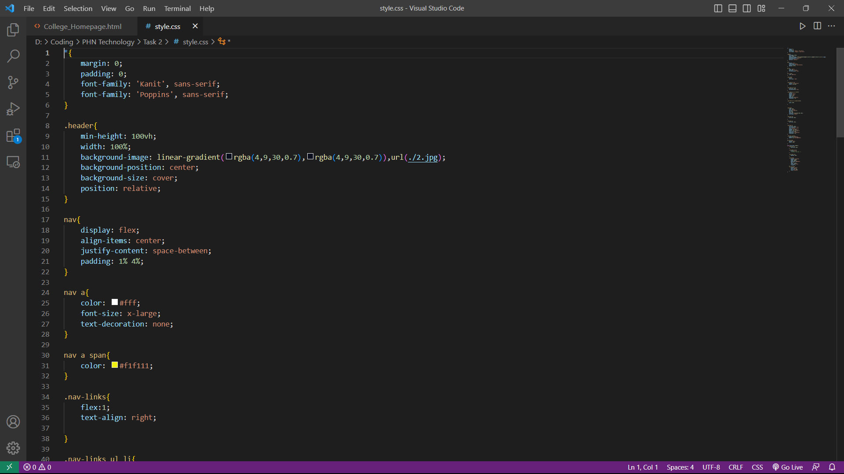

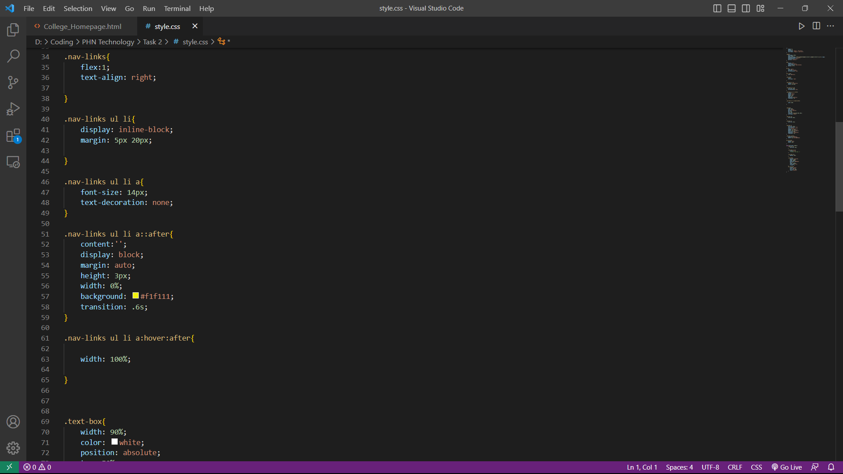

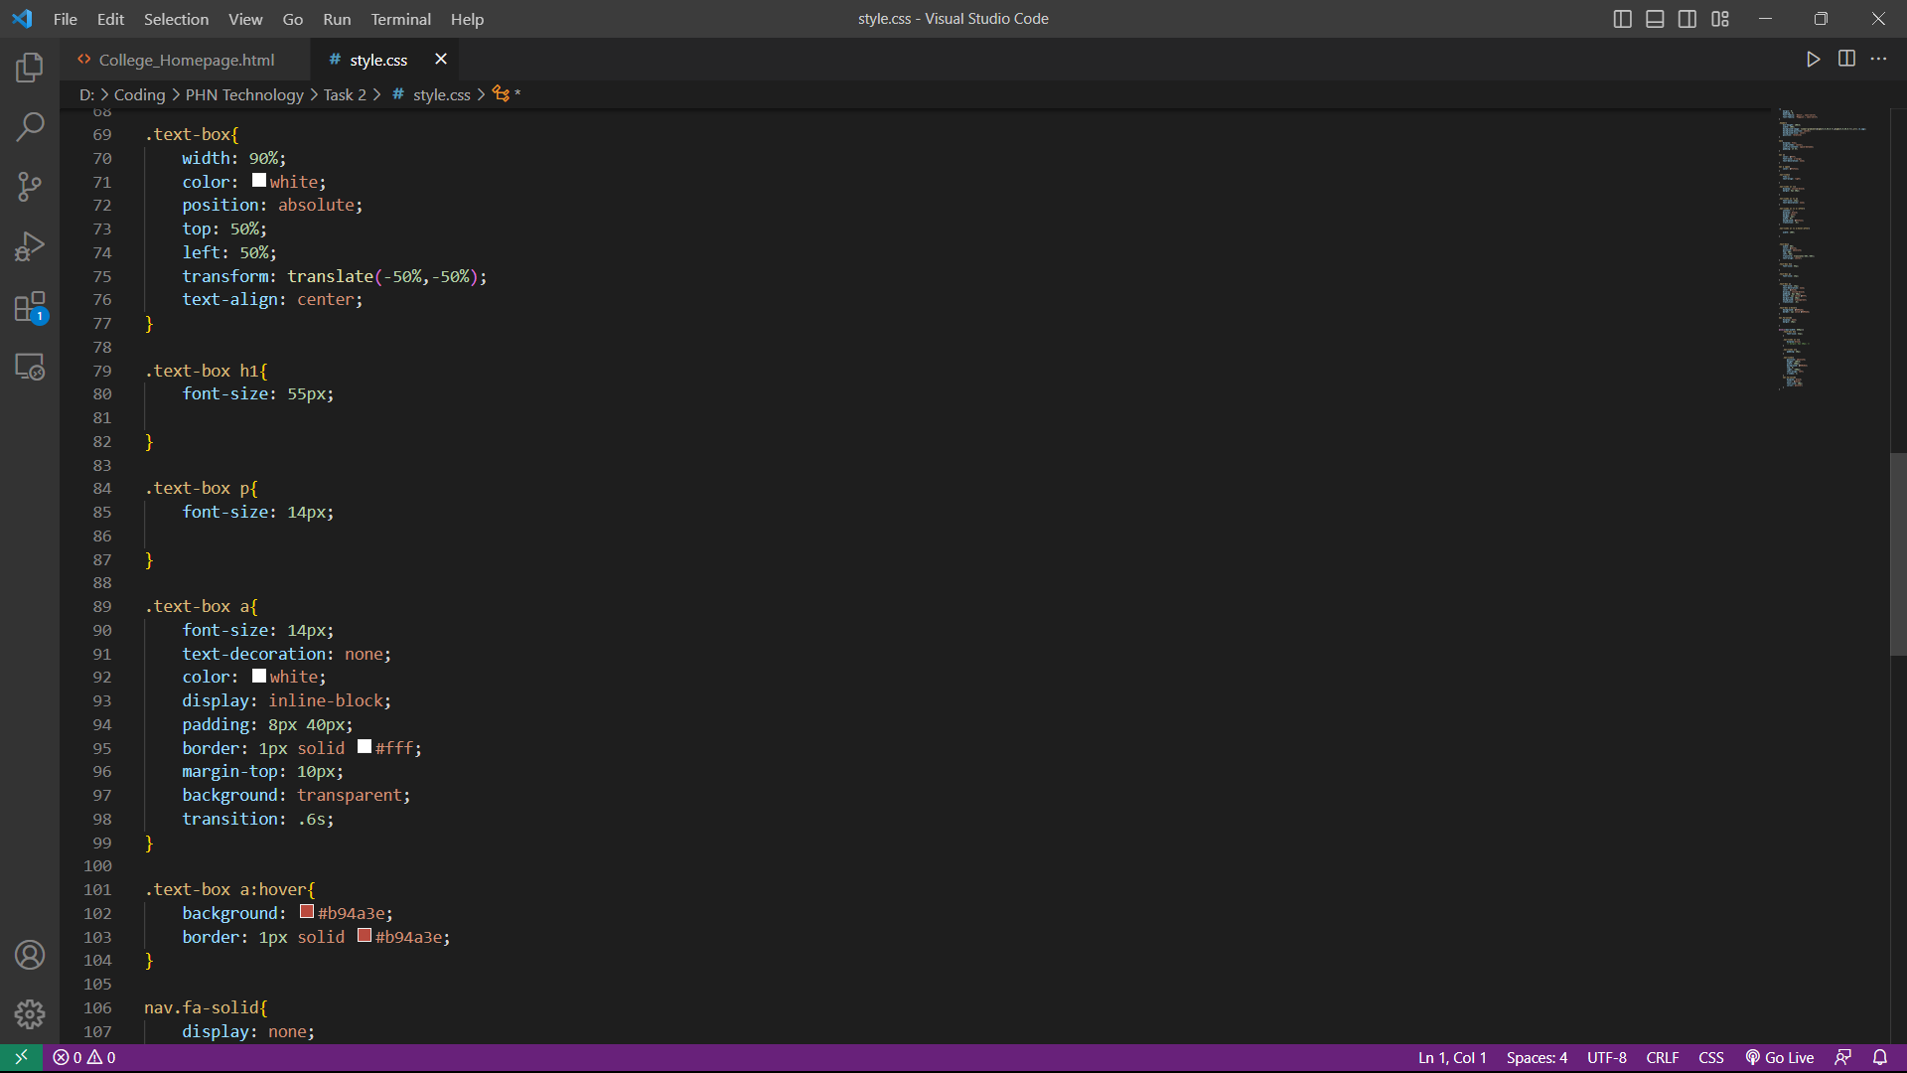

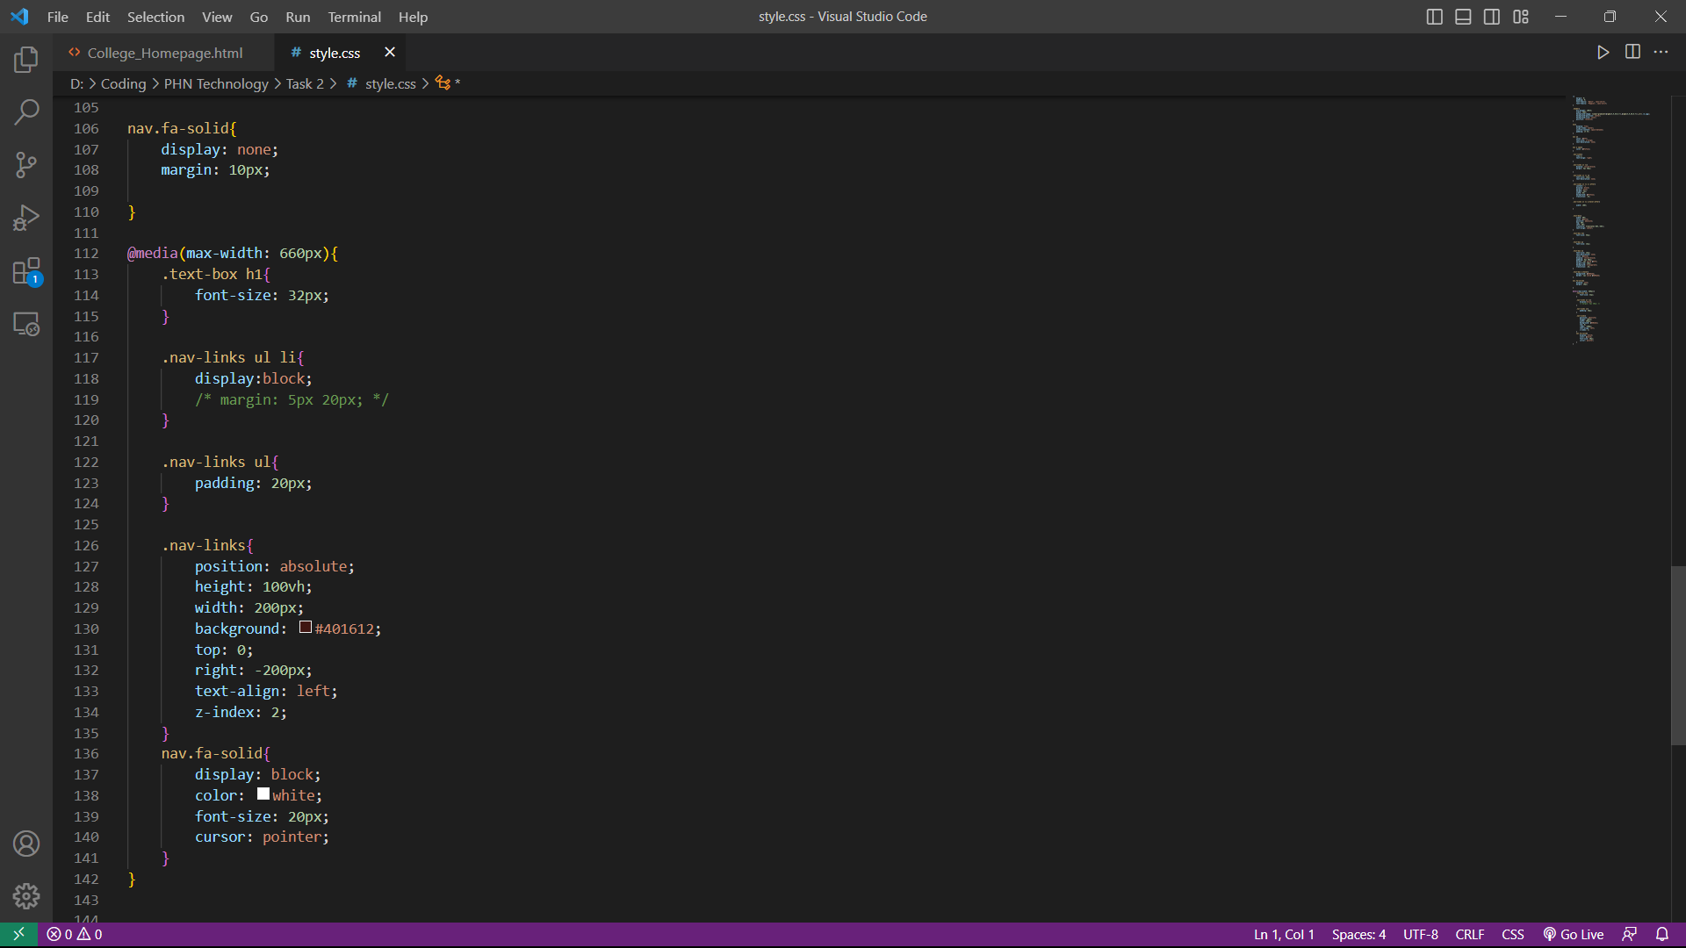

**Homepage Design**

